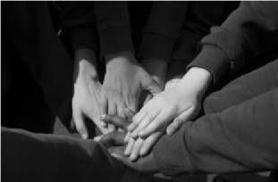

Newsletter 1 2025

Dear Families,

Well that was a marathon term wasn’t it? After 8 weeks of learning and making incredible progress – our children are definitely ready for a break!!

I do hope that those of you who could make it enjoyed our Harvest and Pledge service today. Watching our youngest children lead the Harvest service really was joyous – and hearing all about our learning through the pledge - again just simply wonderful. It never ceases to amaze me how incredible our children and staff team are and how much they achieve as a result!!

I have attached our information to our families to you all again – there is lots of information in here regarding life at All Saints and it might be with you all having a read again – we have had lots of uniform violations this term and lots of questions asked – the answers of which could have/can be found in here!!

Our attendance and punctuality really have not been good this term. We had lots of families arrive back late for the start of the year and since then lots of children have had odd days off here and there and we have had LOTS of holiday requests forms! Please remember we do not authorise any holidays during term time and will issue PCNs per parent per child for any holidays taken.

In addition - we have LOTS of children turning up late every day – please ensure your child is here for the gate at 8:38 (Juniors) and 8:40 (Infants). If your child arrives just five minutes late every day – not only have they already missed essential learning but across the year will have missed 6 days!! Our House Captains are working super hard on attendance and even delivered an assembly to the whole school – so huge thanks to them!

Thank you to all of you who came to our phonics and maths workshops – we had over 80 families attend these events – so huge thanks for taking time out of your busy lives to attend – we hope you found them useful – as always - any questions do just ask!!

And finally – we last ran a competition for our postcards when our current Year 6s were in Reception – and we are just about running out! I spoke to our children in assembly today – if your child would like to design a postcard for us to make up - then if they can do so over the half term break (on A4 paper please) and bring it in on Monday 3rd November – we will choose some winners and get them printed up!!

As always, your child’s curriculum for next half term is on our websites, so do please have a look. I hope you have a wonderful break with yours and look forward to seeing you all ON TIME on Monday 3rd November.

Best wishes,

Susannah

Values Award

Sponsored by our AMAZING PTA!!

Each term the staff nominate a child who they believe has fully embraced and embodied our values of LOVE, RESPECT & FORGIVENESS – I then decide who should receive the award!

This term the award goes to…

Alexandra Dozha

Congratulations Alex and thank you for living through our values of

LOVE, RESPECT & FORGIVENESS!!

**ATTENDANCE**

The National Figure for 2024/25 was 94.8%
The current National Figure is: 94.48%

Our target for 2025/26 is 97%

Infant Attendance 98.1%
Junior Attendance 96.3% - 11 children have attendance below 90% and therefore have persistent absence…

**Learning Round Up**

Ducklings

The first term of the school year in any Reception class always feels like a journey in itself. Our youngest pupils arrived quietly and cautiously in September and in a matter of weeks they’re showing confidence with all the new rules and routines in school and displaying super attitudes to their learning. They’re not so quiet now as they explore all the activities in class with their new friends and it’s great to see them so settled already. The Year One children in Ducklings class have been extremely busy adjusting to life in ‘the pod’ and the more formal learning environment for their English and Maths lessons. They’ve been enthused by our topic work, learning all about the town of Reading. Our field trip around the local area was a particular highlight and the children felt and looked particularly grown-up walking around the streets with their own clipboard and map. Well done to all for a very successful start to the year.
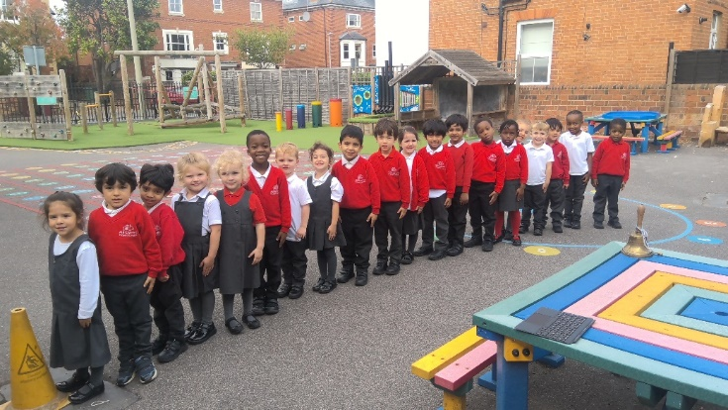

Cygnets
And the first term is complete! Cygnets have had a fantastic time and we have already done SO much learning...
We got to be architects and design and make our very own houses, we have explored habitats and microhabitats around the school, we have written stories about monsters and written silly nonsense poems. We grew some perfect plants and learnt to be magnificent map readers - and all in only 7 and a half weeks. Oh... and we fitted in a walk around our local area and a science lesson in Dippy Park!
Have a safe and happy break with lots of relaxing and we'll see you back in November!

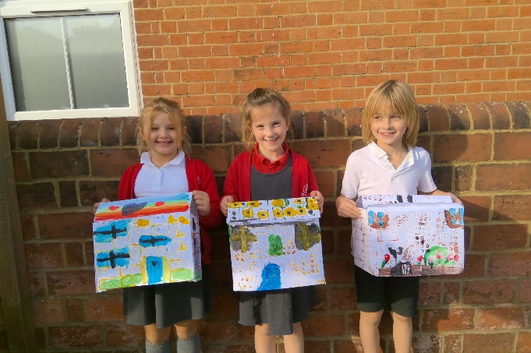

Year 3
I am pleased to say that all the children have settled in remarkably well, embracing the new challenges and opportunities this term has brought. It has been a delight to see them so engaged in their learning, demonstrating enthusiasm, curiosity, and creativity in all areas.
This term, we embarked on an exciting journey through history, exploring Prehistoric Britain. The children showed great interest in learning about how people lived during the Ice, Stone and Bronze Ages, and they worked hard on writing their very first history essays. A highlight of this learning experience was our trip to Reading Museum, where the pupils participated in a hands-on session about prehistory which truly brought the topic to life for them.
In addition to history, they have also made great strides in their English lessons, where they wrote fantastic stories, full of imagination and creativity. In Reading sessions, they explored a range of interesting poems, building their comprehension and analytical skills. During Art lessons, children expressed their creativity in a variety of artworks, and I have been immensely impressed with their efforts and artistic flair. The pupils also began their fascinating journey into learning Latin, exploring the basics of the language and its connection to English vocabulary. It was a very busy but very fulfilling term!
As we look forward to the upcoming half-term break, I want to thank you for your continued support throughout this term. I wish you all a restful and enjoyable half-term break and look forward to seeing the children back, refreshed and ready for more exciting learning next term!
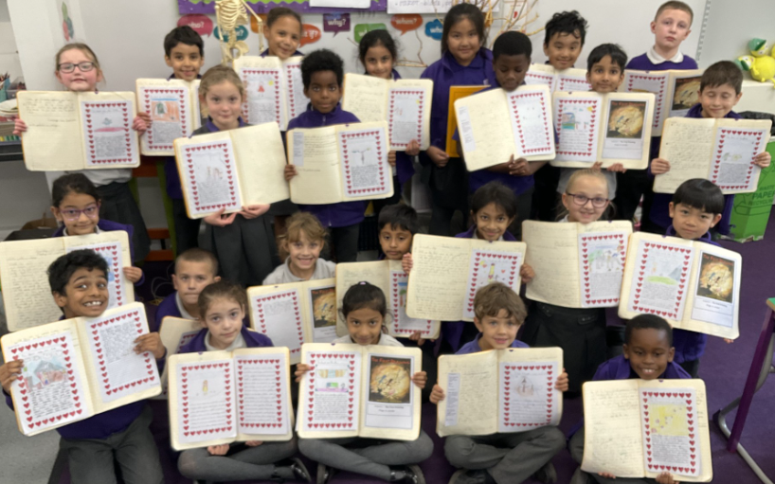

Year 4
What a packed start to the year we have had in Year 4! I have thoroughly enjoyed getting to know all the children and being welcomed into the All Saints Family! We have been so busy - from planning and preparing the Roman Feast, to visiting Silchester and attending concert rehearsals.
I have particularly enjoyed reading the children’s independent writing in English. They have written some incredible legends based on ‘The Mermaid of Zennor’ and most recently poems inspired by ‘Tar Beach’. I have been blown away by the way children have put so much thought and feeling into these.
As you know, the times table check will take place during the Summer term. The children have worked incredibly hard to learn times table and division facts through both maths lessons and weekly arithmetic lessons. It is fantastic to here so many talking about their learning at home too.
The children should be so proud of what they have achieved so far. I can’t wait for the exciting activities that will take place next half term, especially the concert! Thank you for your continued support and have an enjoyable and restful half term.
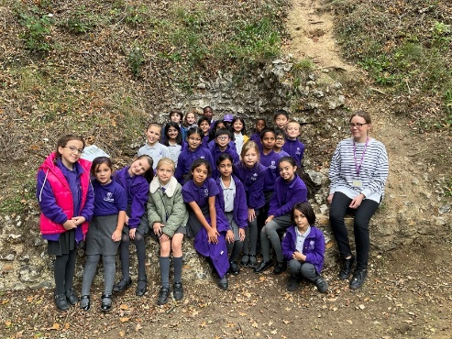

Year 5

We have had a wonderful term to kick off our year! Year 5 have been working incredibly hard across the curriculum, with some fabulous pieces of learning to show for it. We have been learning about the Benin Kingdom in history and have written some amazing biographies about the incredible achievements of the Hidden Figures at NASA, and the impact AI and robotics can have on our lives! The class has been focusing hard on maths, mastering place value, and most recently have shown incredible skill using our new learning to solve problems about time. Taking part in the Big Draw has given them an amazing chance to explore the links between us and our communities through art, and they can’t wait to share their creativity. I have been so impressed with all their learning this term and I am very excited about all that is to come in Autumn 2. Well done, Year 5 and have a wonderful half term break!

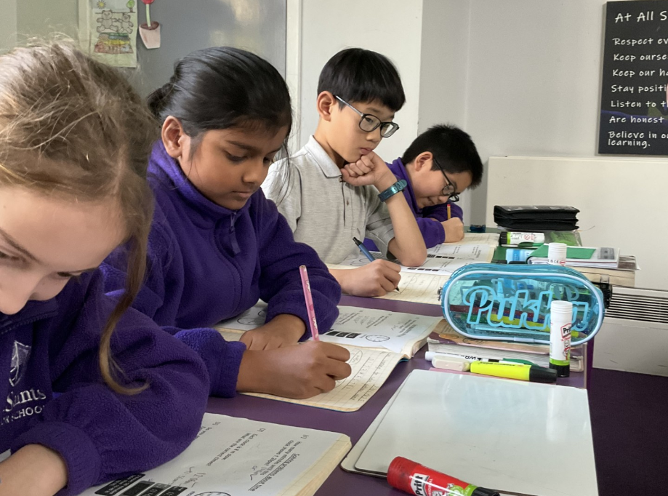

Year 6

We have had a truly fantastic first term in Year 6!
It has been jam packed with lots of hard work but also lots of fun! They have shown brilliant focus and determination. In English we studied Windrush child, a beautiful story that opened our eyes to the struggles the Windrush Generation faced. Then we moved on to The Arrival by Shaun Tan which has no words but still managed to make us feel some big emotions! We wrote our own versions of the story for characters we created which was really creative and fun! We have loved the challenge of Maths this term, getting to grips with Effective Maths and doing lots of revision to get us SATS ready! In Science we've looked at living things and their habitats and we did a really horrible experiment involving mouldy bread! History has been all about the Industrial Revolution, learning what the Victorians were like and the importance of steam power. We also went on a school trip to Reading Museum to learn all about what the Industrial Revolution was like in Reading! Lots of interesting learning about biscuits! In music we studied film music which was so interesting, we particularly liked the silent films that could have the whole mood and meaning changed by the music used. In Art we have been working collaboratively! Working on group pieces as well as individual pieces that come together to show we can collaborate in many different ways! Towards the end of term, we completed our first SATs mock of the year which they tackled so sensibly and calmy. Some super great results and a good focus of what we need to work on moving forward.
Rest up and have fun over half term, come back ready to work hard!

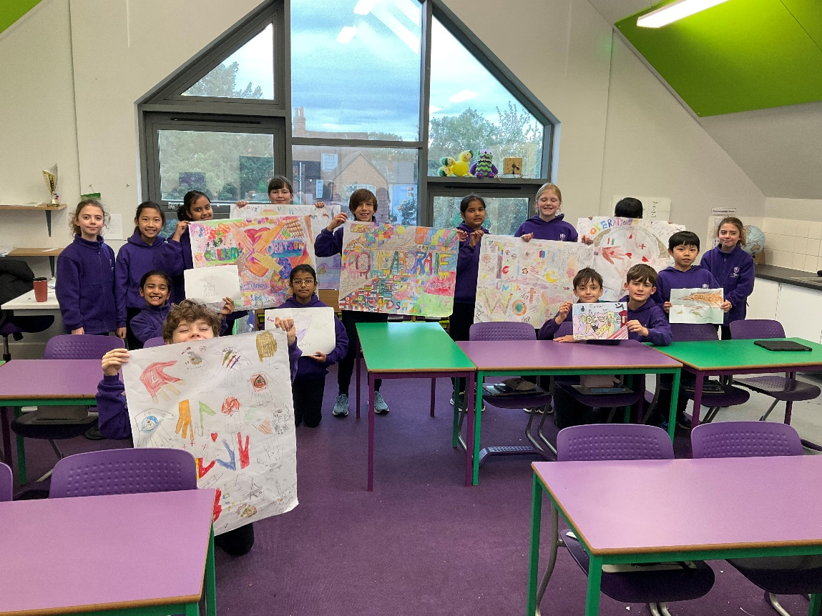

**UPDATE FROM OUR INFANT GB**

I hope the first part of the autumn term has been good for you and your children, both for returning families and those new to All Saints, to whom I extend a very warm welcome.

The Governing Body meets once per half term so we had our first meeting of the new school year a few weeks ago. As usual, it was a busy agenda. It involved the election of the chair (me) & vice chair (Sarah Charlton) for the year, allocation of lead governors for our priority areas such as safeguarding, finance and curriculum and agreement of governor training plans. We also discussed the infant school's development priorities for this year, which are focused on Oracy, the implementation of the new Teaching, Learning and Marking policy, and the new Maths scheme. With regard to the latter, it was really pleasing to hear that there was such a high turnout for the recent session with families on the Effective Maths scheme. Also, at the Governing Body meeting, we reviewed the feedback you provided in the annual survey near the end of last term. The meeting had a strong safeguarding focus too as we have to ensure that staff and governors are up to speed with the updates made to safeguarding requirements that are made by the government every September.

Away from formal meetings, governors continue to visit the school periodically to monitor aspects of the school's activities. One of the highlights for governors is being able to sit in on the periodic book looks undertaken by school leaders, which we do several times per term, and reports from these visits are provided to subsequent governor meetings. It has been very pleasing in this term's visits to already see the positive impact of the new Teaching, Learning and Marking policy and how everyone is engaging enthusiastically with the new Maths scheme.

Finally, a plea - we still need new people to join us on the governing body. It obviously does involve a time commitment, but it is rewarding and is more fun than I'm sure I've made it sound here!! If you would like to find out more about the role, please get in touch with me (stevedaniels@allsaints.reading.sch.uk) or speak to the Head.

Happy half term!
Steve Daniels
Chair of Governors, All Saints Infants School

**UPDATE FROM OUR JUNIOR ACC**

From the Anthem Community Council - written by ACC Chair Liz Kenny

Dear Families,
Welcome to the end of the first half term!
If you’re new to the school you may be wondering what is the “ACC” and what do we do…
Well, the ACC is an acronym for the Anthem Community Council. A local school governing body designed to enable local people to get involved in the life of the school and its standing in the community. It is intended as a sounding board to gauge the opinions and ideas of parents, carers, students, staff, and the community. I’m the chair, Liz Kenny and I love being able to support the school in this endeavour.
To this pursuit, it’s my pleasure to communicate to you how a local organisation called, “Green Park” volunteered their time in the summer holidays to ensure your children started school this academic year with a beautiful revitalised playground area.
They pruned, painted, tidied, fixed and cleaned! They also donated a brand new picnic bench and Friendship bench for the playground. They were incredible!

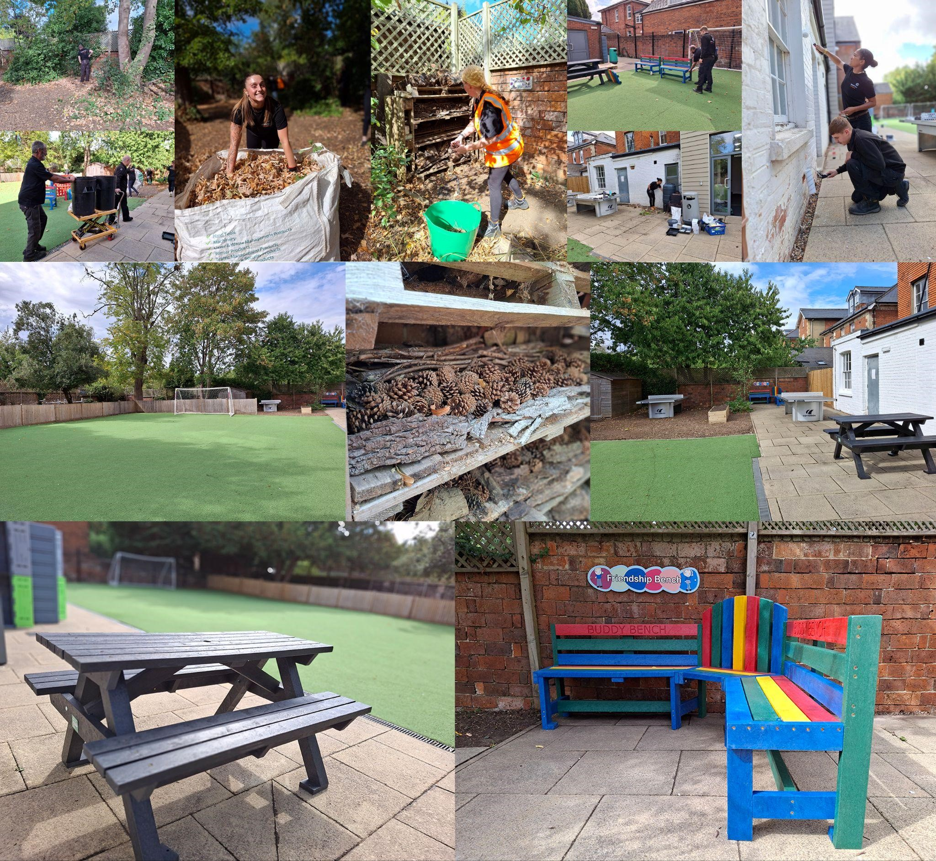

We’d love to have more members join the ACC. If you’re interested in being a parent volunteer and interested to know more about the role of the ACC please message Elizabeth
Kenny (Chair of the Anthem Community Council): lkenny@allsaints.anthemtrust.uk

Have a wonderful half term break!

