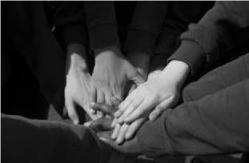

Newsletter 3 2026

Dear Families,

I always write this newsletter after I have read the learning round up – as that way I start with my heart singing! It really is phenomenal what our children achieve in such a short space of time and this term has been no exception – so enjoy!

I do have to give a quick shout out to our amazing Year 5 cyclists – the weather was absolutely brutal to them last week and yet they never stopped learning, cycling and smiling – I am hoping that they are now super safe on the roads and have dried and thawed out just a little bit!

We had the most amazing trip to the Hexagon this week to watch the Gruffalo’s child – courtesy of our PTA! Our children were spellbound as they watched the events unfold on the stage and it reminded me how lucky we are to have this wonderful resource on our doorstep!

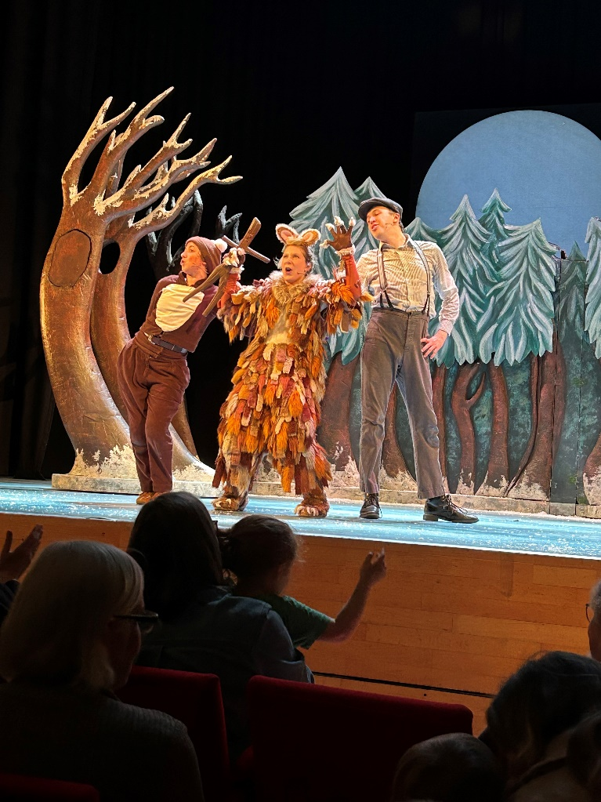

Over half term we would ask that you take the opportunity to check and replenish your child’s pencil case please! This is what they should contain – thank you!
- HB pencil x 2 and of a decent length!!
- Rubber
- Ruler
- Sharpener
- Pritt Stick
- Coloured Pencils
- Dry Wipe Black Pen for whiteboard work (fine nib)
- Green fine liners for levelling up work
The trust our Junior School belongs to are currently fundraising for their campaign - Anthem Aspire – to find out more about what they are doing and why – do please have a look here!!
Anthem Schools Trust - Aspire
I do hope you all manage to have a wonderful break and look forward to seeing you all on Monday 23rd February.

Best wishes,

Susannah

Values Award

Sponsored by our AMAZING PTA!!

Each term the staff nominate a child who they believe has fully embraced and embodied our values of LOVE, RESPECT & FORGIVENESS – I then have the nearly impossible task of deciding who should receive the award!

This term the award goes to…

Emily Butler

Congratulations Emily and thank you for living through our values of

LOVE, RESPECT & FORGIVENESS!!

**ATTENDANCE**

The National Figure for 2024/25 was 94.8%
The current National Figure is: 93.4%

Our target for 2025/26 is 97%

Infant Attendance 98.2%
Junior Attendance 96.7%

You may notice some new signs going up across both schools over the next few weeks – I am hoping they will be a constant reminder that every minute and every day definitely counts!
Absence most definitely = a wasted opportunity!

**Learning Round Up**

Ducklings

We’ve managed to fit a huge amount into this relatively short term. The topic of journeys has resulted in some wonderful learning experiences for our reception children, ranging from imaginary rides on magic carpets to watching footage of the first moon landing. Year One children have immersed themselves in their topic of China, with a clear highlight being planning, making and eating a stir fry. They also loved the lesson sampling all sorts of Chinese food. They’ve learned all about the many landmarks in China and the Chinese new year celebrations. In this last week of term, we were all extremely lucky to go to the theatre together to watch The Gruffalo’s Child which was a real treat for the end of term.
Wishing you all a lovely half term break.
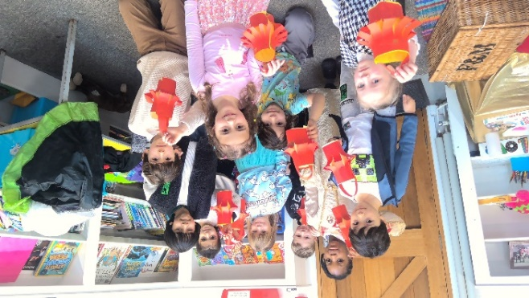

Cygnets
It’s been a fantastic term for Cygnets, full of hard work and exciting learning. Year 1 and Year 2 have both been working incredibly hard in English, exploring and writing lots of different types of poems. In science, Year 2 have been busy making circuits and experimenting with static electricity in their science lesson and have been really taking in how much we should stay safe around batteries. As a class, we even travelled all the way to China (in our imaginations!) where we learned about the country, cooked our own delicious stir-fries and created lapbooks to show everything we had discovered. We also enjoyed a special trip to see The Gruffalo’s Child on stage at the Hexagon, and celebrated filling our star jar with a well-earned pyjama day. Here’s to the same hard work next term – but hopefully with a little more sunshine! 🌞

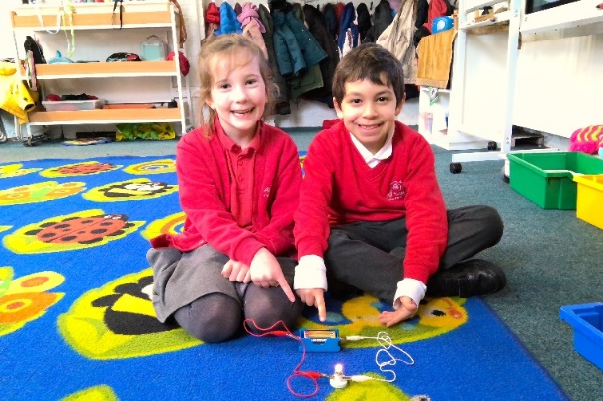

Year 3
As we come to the end of another busy half term, I would like to take a moment to share how proud I am of everything the children have achieved. It has been six weeks full of curiosity, enthusiasm and fantastic learning and it has been a real pleasure to teach the class.
This half term, we have explored a range of exciting topics, including Fossils, The Shang Dynasty and Natural Disasters. In English, the children produced some wonderful work, writing their own myth and a newspaper article, which allowed them to develop their creativity, vocabulary and editing skills. In Science, the children enjoyed investigating different types of soil through practical experiments and, across the curriculum, they have taken part in learning experiences that have encouraged creativity and critical thinking. In Art, the children have worked hard to improve their drawing skills, producing some detailed and imaginative pieces.
The Year 3 children have approached each challenge with enthusiasm and resilience, showing a fantastic commitment to their learning every day. It has been a joy to see the pride they take in their work and the progress they have made throughout the half term.
Thank you for your continued support. I wish you all a restful and enjoyable break and look forward to seeing what the next term holds for my fantastic class.

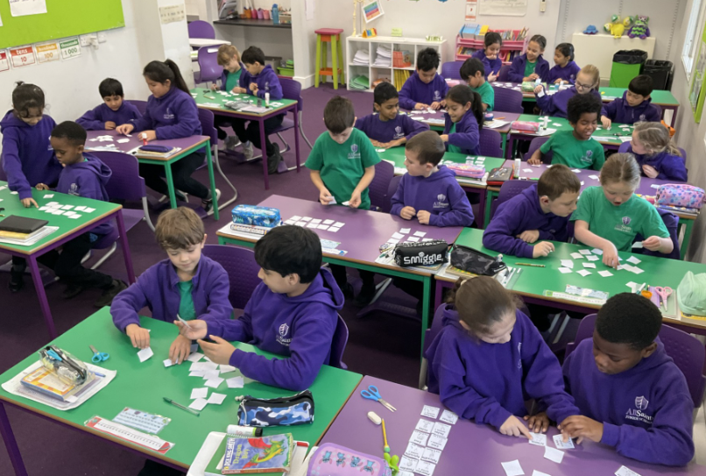

Year 4

This half term, children have continued to demonstrate and show great enthusiasm towards their learning. In English, children have greatly enjoyed the texts ‘The Selfish Giant’ and ‘Winter’s Child’, which inspired our writing pieces this term: a setting description and a fantasy sequel. They have been totally enthralled with our class reading text too, ‘Tamarind and the Star of Ishta’ and we have been finding it hard to put the story down! We continue to build and expand on our maths knowledge and have tackled decimals and deepened our place value understanding. Our Science lessons on sound have been very engaging and the children have particularly enjoyed investigating volume. We explored the Anglo-Saxon period in History allowing us to find out what happened after the Romans left.
Our class mindfulness sessions have focussed on ‘Grattitude’, and we have been trying to develop and ‘Attitude for Gratitude!’. We learnt that being grateful doesn’t just make us feel good, it also positively impacts others. This has linked beautifully to our pledge – to perform a random act of kindness. Children have continued to work on their Oracy in focussed lessons and throughout the curriculum, particularly learning about word choice and giving reasons for their thoughts and opinions.
We wish you a wonderful restful break and look forward to seeing you in the new term.

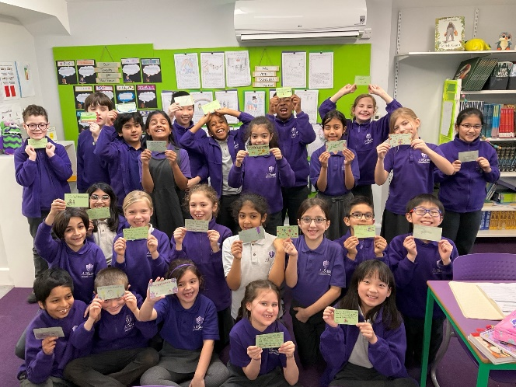

Year 5

Year 5 have had another fantastic term! Our term has been filled with brilliant learning on fascinating topics including the sense of belonging in English, slavery in America and the ramifications this has had on English history, and too many maths topics to count! Year 5 have worked exceptionally hard to keep up their amazing learning towards the end of the term while also learning about cycling and road safety, even during the harshest of weather, and a trip to the museum and abbey. We are very much looking forward to another term of brilliant learning, brilliant concentration and brilliant discussions thanks to the new oracy skill we have been learning about! Have a brilliant half term, see you soon!

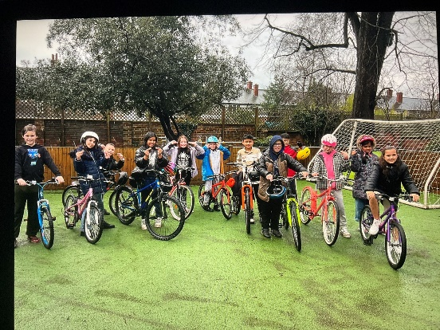

Year 6

Year 6 have been fab this half term! We've been working so hard, keeping really excellent focus and applying ourselves across the curriculum! In History we delved into Civil rights and learnt some really important things about equality and what people have sacrificed to achieve it. In English we had a brilliant time studying Hugo Cabret and wrote fantastic biographies on famous filmmaker Georges Melies. Then we looked at the Suffragettes which linked beautifully to our history and Civil rights. We're gearing up to write some super persuasive letters and really show off our formal writing skills! Also linking to this was our Reading book 'The Little Match Girl Strikes Back' which is a spin on Hans Christian Anderson's 'Little Match Girl' but with lots of exciting twists! We've done a real variety in maths, geometry, fractions, decimals and we even a brilliant visit from Greg! We've been looking at street art and graffiti in Art which has been really fun and creative. In Computing we have been learning all about AI and the applications, concerns, positives and ethics which has proven to be very interesting. We completed some more SATs assessments and showed some stunning progress. A truly action packed half term with lots of lovely learning crammed into 6 weeks!
Have a peaceful half term break and come back refreshed and ready to go again!
Well done Year 6, you are fantastic!

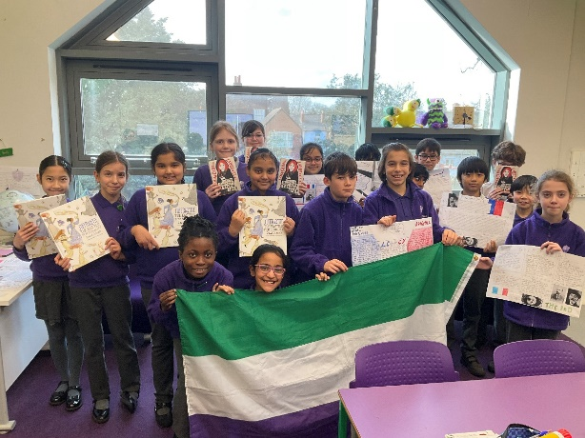

**UPDATE FROM OUR INFANT GB**

Another half term has raced by and somehow we’re halfway through the school year. There has, though, been plenty of governor activity squeezed in since the start of term. We’ve had a superb response to pleas for people to join us and should soon be able to be able to enjoy the rare luxury of a full cohort of governors! I’m looking forward to the new governors joining us over the coming weeks. Watch this space!
In addition to the formal governing body meeting each half term, each governor has the opportunity to get involved in monitoring visits at the school. In the last few weeks alone, governors have been able to join Mrs Daniel and Miss Wathey in book looks seeing evidence of the terrific progress being made by the children. In addition, there was a chance for governors to be in school during the latest review of the implementation of the Effective Maths curriculum - the enthusiasm and engagement in the Maths sessions shown by the children in each class was hugely impressive, certainly nothing remotely like my experience of Maths classes when I was at school! The Effective Maths scheme seems to be very well designed and I hope that you are also enjoying supporting your child’s Maths learning.
Then last week, I was able to be at a joint Junior/Infant school assembly. I was invited to monitor the work of Infant school children in the School Parliament. The four ASIS children that had been nominated for the School Parliament this year were delivering the assembly with the school leaders from the Junior School. I must admit I was blown away by how well the children spoke, they delivered their presentation and answered several questions with such aplomb!
Finally, I must mention one other thing. I have been in the school a lot these past few weeks, one unnamed member of staff even queried if I was moving in! On each visit, and I can say the same for visits in previous terms too, it has struck me how calm ASIS is as a learning environment and how wonderfully behaved the children have been. It really is a major strength of the school.
Happy half term!
Steve Daniels
Chair of Governors, All Saints Infants School

**UPDATE FROM OUR JUNIOR ACC**

Dear Families,

One of the best parts of being a member on the ASJS’s ACC is working with the Eco Warrior Student Leadership Team.

It is with great joy I get to introduce our new Eco Warriors Leaders:

Head Eco Warrior: Amelia and Eco Warrior Secretary: Kaleema

Our new Eco Warriors are embarking on some exciting and important work as they begin to shape a greener future for our school. They are starting by building a strong Eco Warrior team, working together to share ideas, take responsibility, and lead positive change across the school community. Their enthusiasm, teamwork, and determination are already shining through as they take on this role!

Over the coming weeks, the Eco Warriors will be investigating food wastage across the school. As well as continuing to nurture and protect the biodiversity of our playground. Watch this space for more updates on their endeavours.

Well done Team on all your hard work this term!

